

**THE UNIVERSITY OF TEXAS AT ARLINGTON, TEXAS  
DEPARTMENT OF ELECTRICAL ENGINEERING**

**EE 5329**

**Distributed Decision and Control**

**TAKE HOME EXAM 1**

**by**

**SOUTRIK PRASAD MAITI**

**1001569883**

**Presented to**

**Dr. Frank Lewis**

**March 6, 2018**

**EE 5329 Distributed Decision and Control**

**Spring 2018**

**Exam Pledge of Honor**

On all exams in this class - YOU MUST WORK ALONE.

***Any cheating or collusion will be severely punished.***

***It is very easy to compare your software code and determine if you worked together***

***It does not matter if you change the variable names.***

Please sign this form and include it as the first page of all of your submitted homeworks.

.......................................................………………………………………………………………........

Typed Name: Soutrik Maiti

***Pledge of honor:***

"On my honor I have neither given nor received aid on this homework.”

e-Signature: Soutrik Maiti

**MATLAB CODE:**

*Formation control function-*

function Zdot = formationcontrol(t,z)

%% Adjacency Matrix of the formation graph

a = [0 0 0.5 0;

0.5 0 0 0;

0.5 0.5 0 0;

0 0.5 0 0;];

d = diag(sum(a,2));

%% Graph Laplacian Matrix

l = (d - a);

%% Offset of the agents wrt leader

del0 = [1 1];

del1 = [1 -1];

del2 = [-1 -1];

del3 = [-1 1];

del = [del0'; zeros(1,2)';del1'; zeros(1,2)';del2' ;zeros(1,2)';del3'; zeros(1,2)'];

%% Setting the value of gamma

gamma = 3;

%% Pinning Gain Matrix

G = [0 0 0 0;0 0.5 0 0;0 0 0 0;0 0 0 0];

%% PD Gain Matrices

kp = eye(2);

kd = gamma*eye(2);

K = [kp kd];

c = 550;

%% Agent Node Dynamics Matrices

aSys = [zeros(2) eye(2);

zeros(2) zeros(2)];

bSys = [zeros(2); eye(2)];

%% Kronecker Products

kron1 = kron(eye(4),aSys);

cL = c*(l + G);

BK = bSys*K;

kron2 = kron(cL,BK);

Ac = kron1-kron2;

%% Leader Dynamics

x0 = aSys * z(17:20);

%% Node Dynamics equation

z0 = Ac*z(1:16) + kron2*del + kron2*([z(17:20); z(17:20); z(17:20); z(17:20)]);

Zdot = [z0;x0];

End

*Simulation and calling the function-*

clear all; clc;close all;

%% Simulating Dynamics for 4 agents and leader

[t,Zdot] = ode23('formationcontrol',[0:0.01:50],[2*rand(8,1);2*rand(8,1);zeros(2,1);ones(2,1)]);

%% Positions of the agents and leader

figure;

plot(Zdot(:,1),Zdot(:,2)) %agent1

hold on

plot(Zdot(:,5),Zdot(:,6)) %agent2

plot(Zdot(:,9),Zdot(:,10)) %agent3

plot(Zdot(:,13),Zdot(:,14)) %agent4

plot(Zdot(:,17),Zdot(:,18)) %Leader

grid on;

title('Positions of agents and leader')

xlabel('x');ylabel('y');

p1 = plot(Zdot(:,1),Zdot(:,2),'s');

p2 = plot(Zdot(:,5),Zdot(:,6),'s');

p3 = plot(Zdot(:,9),Zdot(:,10),'s');

p4 = plot(Zdot(:,13),Zdot(:,14),'s');

p = plot(Zdot(:,17),Zdot(:,18),'o','MarkerFaceColor',[0.91 0.41 0.17]);

legend('1','2','3','4','Leader')

hold off

%% Plot Animations

for k = 1:size(t,1)

p1.XData = Zdot(k,1);

p1.YData = Zdot(k,2);

p2.XData = Zdot(k,5);

p2.YData = Zdot(k,6);

p3.XData = Zdot(k,9);

p3.YData = Zdot(k,10);

p4.XData = Zdot(k,13);

p4.YData = Zdot(k,14);

p.XData = Zdot(k,17);

p.YData = Zdot(k,18);

drawnow limitrate

end

drawnow

%% Velocities of agents and leader

figure;

plot(Zdot(:,3),Zdot(:,4)) %agent1

hold on

plot(Zdot(:,7),Zdot(:,8)) %agent2

plot(Zdot(:,11),Zdot(:,12)) %agent3

plot(Zdot(:,15),Zdot(:,16)) %agent4

plot(Zdot(:,19),Zdot(:,20)) %Leader

legend('1','2','3','4','Leader')

grid on;

title('Velocities of agents and Leader')

xlabel('V_x');ylabel('V_y');

**RESULTS:**

The following figure shows the position of agents and the leader.

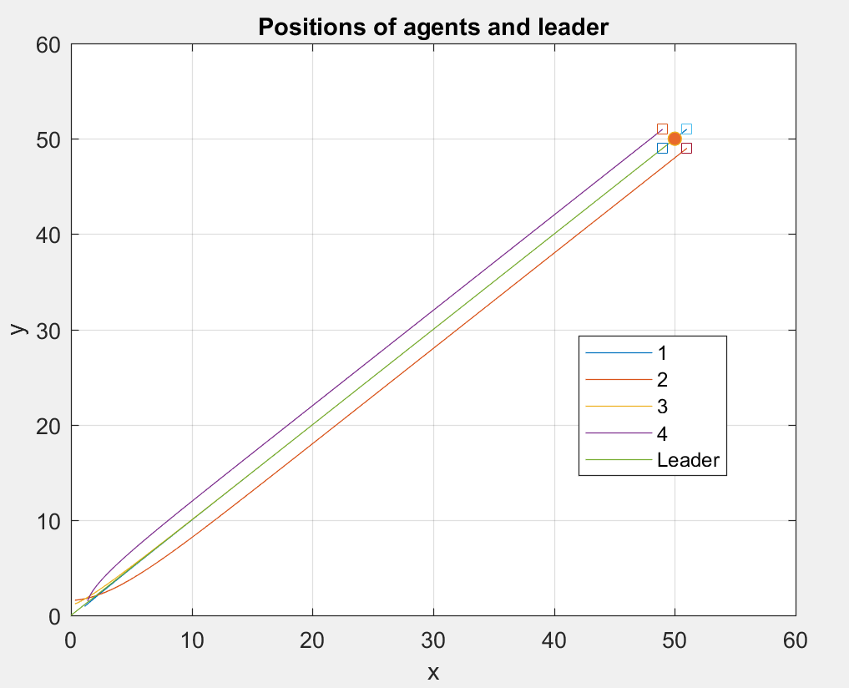

The following figure shows the velocities of agents and Leader.

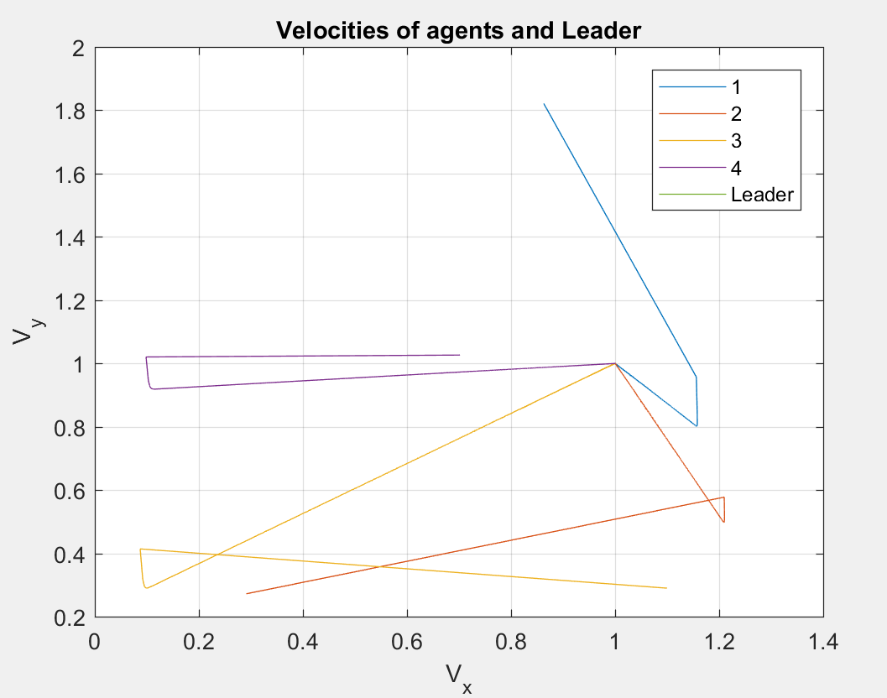

Thus, from the above two figures we can see that the agents finally reach consensus with leader.